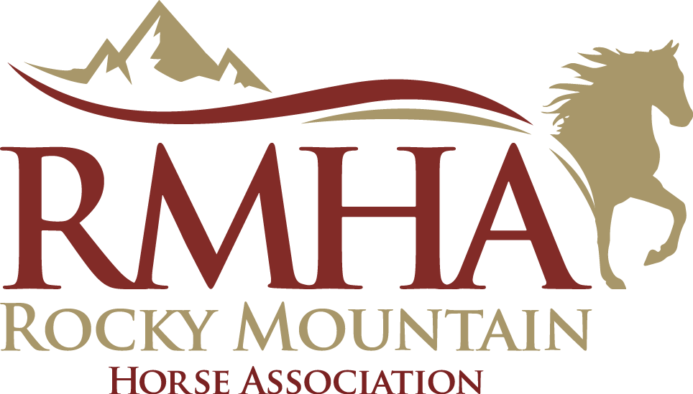

From the RMHA Publications Committee, THANK YOU for an Outstanding 2025!
Serving the RMHA community of breeders, trainers, owners, and businesses has been a privilege. As we embark on the Winter-Spring 2026 edition, we are excited to present a report that is cause for celebration! Thanks to the overwhelming support from our members, we have been able to showcase the versatility and beauty of our incredible breed, as well as capture your inspiring stories. It is with your support that this magazine became such a success in 2025!
Financials: Over $15K in profit!
• Projected 2025 net profit is +288% vs 2024
• Expenses are projected to decrease 35% for 2025 vs 2024
Increased Member Value
• No increase in costs to members
• Profits from the magazine supported member programs:
- International Committee received over $8,000 that increased paybacks and provided Photos by Scotty for championship winners
- Horse Illustrated “Best of Breeds” Ad
Increased Magazine Reach
• 1,900 magazines to be shipped for Summer–Fall 2025
• 720K Facebook average views per year; Up to 180K views per Facebook Reel
• Over 40K expanded social media reach via sharing to key gaited horse groups
• Over 100K reach via Horse Illustrated advertisement
Your 2026 designer, Cheri Prill from Stunning Steeds!
Cheri has garnered widespread acclaim, winning multiple awards from the American Horse Publishers for her exceptional photography. Her stunning videos have graced international promotions, prestigious events, television programs, and online platforms, elevating her reputation globally. Notably, her work has found its way into museums and private collections worldwide, gracing the pages of renowned equestrian magazines, books, calendars, and various equestrian products and merchandise. Her work can be viewed via her website.
Stunning Steeds Equine Photography Video Design
2026 Winter-Spring 40th Anniversary Collector Edition
RMHA Magazine Advertising Opportunities
Ad design is included in the price of your ad, or you may use your own designer. All advertising must be approved by the RMHA.
Ad Size | Price  *Design is included | Dimensions | Bleed
Full Page | $400 | 8.5" W x 11" H | .25” each side
Half Page | $300 | 8.5" W x 5.5" H | .25” each side
Quarter Page | $200 | 3.625" W x 4.55" H | .25” each side
Business Card | $125 | 3.5" W x 2" H | .25” each side
Payments are due by January 20, 2026 PAY HERE
For payment by credit card (4% fee) use payment link or mail a check to RMHA or by check to RMHA, THE BLUEGRASS STOCKYARDS 4561 IRON WORKS PIKE, STE. 156 LEXINGTON, KY 40511
Advertising Contact: To purchase an ad, contact Barbara Rector at 410-913-4848 or brector28@outlook.com. Upon purchase, you will receive instructions for submitting photos and materials. All ad materials are due by January 20th or earlier.
File Requirements
• Preferred format: PDF with embedded fonts
• Other formats: High-resolution JPG or TIFF, 300–350 dpi, CMYK/Grayscale
• .25 inch margin bleed required
• Text may be submitted as .doc or .rtf (do not embed photos)
Graphics Requirements
• Images must accurately depict Rocky Mountain Horses
• No logos or imagery referencing other registries or associations
• All gait photos must comply with RMHA Show Rules
Copy Requirements
• Text must align with RMHA promotional intent
• No references to show achievements or registration with other breed organizations

